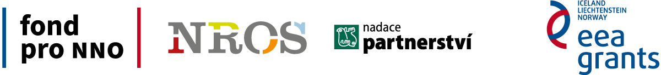

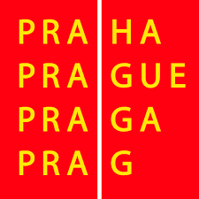

Cookery courses organized by the non-profit organization SIMI will help eliminate stereotypes of Czechs towards foreigners

SIMI Press Release, October 21, 2014

The non-governmental organization SIMI (Association for Integration and Migration) launches series of activities intended for the Czech public in order to support their better mutual coexistence with foreigners, who have been increasingly settling in the Czech Republic in the last years.

Discussions and workshops at schools
SIMI offers an interesting combination of discussions with migrants from different countries and creative workshops for students of primary and secondary schools in Prague and Central Bohemia. Through discussions, students will have an opportunity to better understand other cultures and to form their own opinion on migrants living in the Czech Republic. Students can also try to cook and to taste chosen traditional food of different countries or they can try to create cultural themes of a particular country under the supervision of professional trainers.

"Our views on foreigners are often shaped by what we hear from the media or from the mediated experience of other people. The opportunity to personally meet migrants from different countries will enable students to better understand their situation," explains Kateřina Dederová, the organizer of the project from SIMI. School events will be held within the project AIM Let's give a chance to (i)mmigrants II from a grant of the Prague City Hall.

Multicultural evenings for the public
Due to the support of the Fund for NGOs, AIM is also preparing eight multicultural evenings for the general public within the project Crossing borders in Prague and Central Bohemia. The events will be focused on life in the countries from which migrants come into the Czech Republic. "Crossing borders means to reduce prejudice and to appeal for greater tolerance in an emerging multicultural society. The evenings should contribute to mediate contacts of members from different cultures in a funny way and to enable Czechs to reconsider their preconceived attitudes towards foreigners," explains the coordinator of the projects Eva Čech Valentová from SIMI the name of the events.

We plan to organize evenings on topics of Ukraine, Kurdistan, Iran, Serbia and others. During those evenings, the migrants themselves will present the history, culture and current political situation of their country and they will be certainly pleased to share their experience of living in the Czech Republic with other guests. "As food is an important part of the culture and it also unites people, it will be possible to taste traditional specialties of a chosen country during every evening. You can collect the recipes or use them as an inspiration on an upcoming Food blog, where you can also find personal stories of those, who prepared the recipes or tips on where to go to eat ethnic food or exotic ingredients in Prague," says Kateřina Dederová.

The first evening will be held on the topic of Kurdistan in the primary school Kladská in Praha 2 on Wednesday, November 12, 2014 from 7 pm. The evening will be chaired by Mr Karim Hussain, a Syrian Kurd, who has been living in the Czech Republic for many years.

Counselling AIM
AIM primarily devotes to free legal and social counselling to foreigners. Therefore, foreigners can turn to us for an assistance within the project Crossing borders, if their rights are violated or if they are being discriminated in the Czech Republic.

More about projects and individual meetings can be found at SIMI webpage www.migrace.com. Activities are implemented due to the support of grants from Iceland, Liechtenstein and Norway within the EEA funds and support of the Prague City Hall.

Contact for media:

Kateřina Dederová
PR Manager
Association for Integration and Migration
Tel. + 420 603839076
E-mail: dederova@refug.cz

