The situation of migrant women on the Czech market of domestic work

Petra Ezzeddine, Vilém Semerák

Introduction – research motivation and basic questions
This study aims to map out and analyse a very specific section of the Czech market and immigration flows; it deals with female domestic workers coming from abroad (migrant women) who work in the field of services provided in households in the Czech Republic (nannies, care workers, cleaning workers, housekeepers, etc.). This phenomenon was almost non-existent in the Czech Republic between 1948 and the 1990s and it is therefore rather unusual or exotic for a substantial part of the Czech public (including public administration). It is, however, obvious that this type of migration not only exists, but – considering the demographic and economic trends in the Czech Republic - its economic and social significance is expected to grow.
23 years after the beginning of transformation, the Czech economy finds itself in a specific situation – compared to the rest of the world it may be considered advanced, but with respect to a number of parameters, it also lags behind its more advanced EU neighbours. From the economic and geographic perspective it is the “country in the centre“, i. e. a country, which is both the source of labour migrating to the sector of services of more advanced economies, and a country appealing enough to attract economically motivated migrants from poorer countries, which may partially replace the above mentioned outflow of labour force and may, in addition, reduce other well-known ills of the Czech labour market (see Chapter 8).
Empirical research studies focusing on this type of labour do exist in foreign literature, in particular in the countries which became a typical target of this type of migrating labour force in the past (see Chapter 2). However, a similar type of research is missing in the Czech environment; quantitative data on migrant women working in Czech households is not available. The only available data comprised qualitative in-depth studies of migrant women – domestic workers from Ukraine (Ezzeddine, 2011, 2013) and the Philippines (Redlová, 2012, 2013), and these were used as the basis for our exploration. Our project is the very first quantitative research of this type focusing on social situation of migrant women (female

domestic workers) in the Czech Republic. It is for this reason as well as because of many problems we had to face during the data collection that it is considered to be rather an attempt for a preliminary mapping exercise (a pilot study) facilitating further research.
With respect to the above mentioned, the questionnaires were made very extensive (see Chapter 3), aiming to comprise as many aspects and features of this type of migration as possible. The research therefore includes analysis of their legal, economic and social position on the local labour market, taking account of the labour migration context. The quantitative research tried to take into consideration, in particular, the actual experience of migrant women (domestic workers) who provide live-in domestic work (they live in respective households) and live-out domestic work (they live outside the households they work for) as well as the situation of those migrant women who perform this type of work only as a complementary employment.
The questions we tried to answer during the research may be divided into six basic problem areas:
- What migrant women (nationality, age, family status) come to the Czech Republic to provide care services in families?
- Why did they choose the Czech Republic? Who helped them come to the Czech Republic?
- How are their working activities organised – i. e. do they work irregularly or illegally (partly or entirely), how is their work remunerated, do they have health insurance and access to medical care? Do they send their wages back to their country of origin?
- Do family ties of these migrant women have a “transnational ties” mentioned in foreign research studies? Which members of their family are “left” behind abroad, how do they communicate with them, are they interested in family reunification?
- What problems do migrant women encounter and how do they try to solve them? To what extent are they aware of counselling services and information that can be provided to them by both state and non-governmental institutions?
- How does inclusion in the Czech society take place? Do they remain isolated or do they have local acquaintances and friends?
Apart from an attempt to provide at least partial answers to these questions we tried, as part of the study, to make a general assessment of economic impacts of this type of migration on the Czech economy (Chapter 7) and on giving brief recommendations regarding the Czech immigration policy in relation to this type of migrant women.

Existing literature on migrant women domestic workers
As mentioned above, the research of migrant women in the Czech Republic – domestic workers - focuses primarily on social practices during migration and on work performance (Redlová, 2012, 2013 and Ezzeddine, 2012, 2013), social and related gender inequalities (Uhde, 2009, 2012 and Souralová, 2010) as well as transnational motherhood (Ezzeddine, 2012). During the research we were also inspired by foreign literature (related to social and economic sciences) covering the issues of migrant women employed as (regular or irregular) domestic workers. Most frequently, the literature focuses on the following five thematic areas:
- Analysis of the migration structure and of impacts of this type of migration on the selected target country. This type of literature covers mainly countries where a similar type of migration has become a tradition, and plays a rather substantial role in the local economy. This may be illustrated by the work of Yeoh, Huang, Gonzalez (1999), which analyses impacts on the Singapore economy, with more than 100 thousand domestic workers already in the 1990s coming from countries such as the Philippines, Indonesia and Sri Lanka, equalling to ca one foreign “assistant” per 8 local households.
- Analysis of migrant women’s motivation (and/or, as the case may be, of impacts on the country of origin). Such analyses focus predominantly on those countries where a similar type of migration has become a systematically organised area – of territories that are relevant for our research it mainly concerns the Philippines. For example, Gorodzeyski and Semyonov (2014) discuss mainly income of the Filipino migrants in contrast with non-migrating population, showing how migration may become another source of income inequalities among the Filipino households. Masselink and Lee (2010) analyse commercialisation of education of nurses in the Philippines triggered by heavy migration of care workers and nurses from the Philippines to a number of more mature economies while the domestic health care remains underdeveloped.
- Analysis of negative phenomena which may accompany this type of migration. This does not include only issues of discrimination, abuse or violence the migrants may be exposed to and which, due to their often vulnerable position in the target country, they can hardly combat. It also includes a difficult formalisation of the work performed in private households, hierarchy of relationships between employers and workers as well as the societal recognition of domestic work as a “real“ work (for example, Sotelo, 2001; Ehrenreich and Hochschild, 2002; Anderson, 2008; Lutz, 2011). Problems do exist in relation to, for example, an efficient use of the migrating labour where “overqualification“ of migrant women in their new positions is often an issue, as well as the subsequent loss of qualifications – see, for example, Raghuram and Kofman (2004) or Man (2004).

- Proposed solutions/reforms, which could influence the situation of migrant women. This includes, for example, Fudge (2011) who analyses the situation of migrant women working in care services in Canada, as well as problems related to the legal position of migrant women and possibilities of regulating this sector. Similarly, van Walsum (2011) discusses the issues of regulation of migrating female/male workers in households in the Netherlands. Godin (2013) describes the Belgian migration policy system („cheque service system“), which helps regularise the domestic work performed by migrant women and leads to reduced informal economy. However, Godin emphasizes that not even this system is able to solve problematic (symbolic and affective) setup of social relationships between workers and employers because such relationships are only reproduced from non-formal to formal sectors.
- Analyses of the specifics of the migrant women’s position on the labour market, explaining the growing involvement of migrant women in domestic work and the related migration feminisation. The most distinct gender theory in migration describing the position of migrant women on labour market, is the theory of „triple invisibility“ showing the reasons for migrant women´s absence on local and global markets invisible at three levels – social class, ethnicity and gender (Brettel, 2000).

This “invisibility” causes migrant women´s professional segmentation into several sectors of the economy such as, for example, textile industry or cleaning and domestic work. The labour market segmented in such manner may also indicate low social and professional mobility. The reason is employers’ demand for gender-conditioned labour force, which is also confirmed by the geographic and demographic typology (Mahler, Pessar 2006).

Research methodology
With respect to non-existence of official data on migrant women employed in Czech households it was necessary to obtain proper data, and the most logical for the given purpose seemed to be a questionnaire survey.

Questionnaire
The questionnaire was rather detailed because of limited existing information on this group of migrant women and our attempt to map out this area. It consisted of 7 sections (see Annex) covering the following:
- Basic information about respondents;
- Motivation and decision-making process regarding their stay in the Czech Republic;
- Position and mobility on labour market;
- Working conditions;
- Family and life in the Czech Republic;
- Experience with (non-governmental) organisations.

In part seven it was possible to provide any other relevant information which was not covered in the questionnaire.
The questionnaire consisted of 47 questions including multiple choice questions; however, only closed questions were included. The expected questionnaire completion time by the interviewer and respondent was ca one hour.
In order to make the questioning easier and to increase migrant women´s willingness to respond to the questions, the questionnaires were translated into other three languages – we had Czech, English, Ukrainian and Russian versions. In four cases the Czech questionnaire was simultaneously interpreted into the Vietnamese language, with other two respondents the questions were asked in the Arabic.
All migrant women were in fact given the chance to provide answers in their mother tongue (or in a language actively used by them) or the interview between the interviewer and the respondent was conducted in such language.

Target population specification

Migrant women targeted by our questionnaire had to comply with the following selection criteria:
- They had to perform domestic work (nannies, cleaning ladies, care workers taking care of the sick and elderly people, etc.);
- None of them had Czech citizenship (the country of origin was not important).
However, the questioning had no regional constraints, i. e. we were interested in migrant women who worked and lived at any place in the territory of the Czech Republic. In fact, however, the limited project scope and resources as well as the methods of searching for respondents (see the following chapters) resulted in the respondents included in the research being active mainly in Prague and/or in other quite important cities with the character of a regional centre or those which were close to such centres (Pilsen, Mladá Boleslav, Kolín, Beroun). Rural and border areas - where in spite of a rather bad social and economic situation (lower wages, higher unemployment rate) this type of migration was not totally impossible - were not sufficiently covered. However, a high number of migrant women could hardly be found there. Nonetheless, some of these areas show high concentration of migrant men and women from Vietnam, which may consequently cause systematic variances in our sample structure.

3.3 Searching for respondents and conducting the survey
Searching for respondents and persuading them to participate in the research was a bottleneck of the entire project. Not only migrants but also the domestic population working in the household service sector often work entirely unofficially and/or do not report part of their income. It is, among other reasons, also because it is very difficult to formalise domestic work in the Czech Republic (both for workers and employers). This logically reduces their willingness to take part in a research of this type. Moreover, migrant women are rather unsure about what exactly is and is not “legal“, as well as about potential implications on their stay in the Czech Republic should their unofficial or illegal activities be revealed.
The resulting effect is that official data which would enable planning, for example, of a stratified selection, is non-existent but there are also no lists that could be used to address migrant women. The remaining possibilities how to address them is either through the media (with a very low efficiency and returnability of questionnaires), or use of experience and contacts of non-profit organizations that provide counselling services to such types of clients.
This was the main strategy applied in our research. The first contacts were provided by the above mentioned non-profit organizations, other contacts came out of the questioning process (contacts to acquaintances from previous respondents). Moreover, associations and representative offices of the countries from which the migrants were assumed to come to this sector of the Czech economy were contacted (Representative Office of the Philippines, Filipino-Czech Association). The interviewers themselves tried to obtain further contacts from students coming from the respective countries – also through ads in the media, advertising similar types of services and through agencies offering such services. Five contacts to migrant women were obtained from ads posted by migrants themselves, as we responded to their ads advertising services in the printed media and on the internet. Another interesting source of contacts was women working for religious assemblies in the Czech Republic.
A maximum possible diversification of contact networks was important in order to reduce the risk of biased selection – should the contact sources come solely from non-profit organizations, which provide help to migrants in difficulties, a non-representative sample would be obtained with a prevailing number of migrant women who had already faced administrative or other problems (trying to solve them through the above institutions).
Another substantial problem was to gain sufficient trust of potential respondents so that they would be willing to speak, for example, about illegal employment or unpleasant practices they could face during their stay in the Czech Republic. Therefore, trained interviewers were involved in the research (often from among collaborators of non-profit organisations involved in migration issues) as well as female interviewers from among students and migrants themselves, assumed to be trusted much more by research participants. The data collection was performed by six female interviewers, one male interviewer and five female interviewers from among migrants.

In particular, the involvement of migrants is considered as very important taking into account the research sensitivity of the issue in question.
No matter how these methods proved efficient, their use was not without complications and risks either:
- A very diverse set of female/male interviewers with diverse backgrounds increases (in spite of training provided) the risk of varied interpretations of questionnaires, in particular when it comes to technical terms – for example, insurance or types of employment contracts. We tried to eliminate implications of similar problems by “double checking” selected questions in the questionnaire through other related information.
- The collaborators of non-profit organisations very often take a critical view of migration-related social inequalities, which they acquired when working with migrants, helping them and dealing with their difficult life situations. However, during our research we did not notice any problems in the course of recording/translating of answers, nor any bias caused by private opinions/interpretation.

Questionnaires were designed as anonymous, however, for practical reasons they were completed and partly translated by interviewers during the research. An attempt to have migrants complete the questionnaires was not successful, mainly due to specific problems associated with uneasy formalisation of this type of work. In spite of this mediation role, migrant women – due to the involvement of nongovernmental organisations and other migrants – were provided with a certain informal security that their data would not be misused.
In order to facilitate subsequent processing, the questionnaires were originally prepared in electronic form; however, for practical reasons the vast majority of them were filled out in a conventional manner and ex-post processed electronically.

The course of the questionnaire survey
Due to the specific nature of issues and problems with obtaining contacts to other respondents, the questioning lasted rather long – from January 2013 till May 2014. It does not follow from the results, however, that the length of the time would have a significant impact on the data obtained, financial data included. The only implication identified included changes (or concerns about changes) in relationships between Ukrainian migrant women and Russian employers associated with the Ukrainian crisis, escalating at that time.

In total, approximately several hundred of migrant women were approached during the field questionnaire survey of which 254 migrants fell within our interest group.
Of that number, unfortunately only 120 migrant women were willing to actively cooperate with us and provide us with information about migration and conditions of domestic work. Finally, 105 questionnaires were usable.
This situation (i. e. a low willingness to provide this type of information) is not, however, unusual with respect to the above mentioned unofficial (and in some cases even illegal) status of these types of employees (Abrantes, 2014). What is more important than a relatively small sample is the selection that was not entirely random as well as the limited scope of information available to us about the overall size of this sector in the Czech Republic, which reduces possibilities of testing the representativeness of conclusions drawn based on this sample (Bernard, Leontiyeva, 2013).

Basic characteristics of the respondents
The analysis included questionnaires from 105 migrant women who made use of either the live-in form (13), or “another” form, i. e. live-out (92) form of domestic work. Women participating in our questionnaire survey were aged 36.4 in average, and came to the Czech Republic for the first time a little less than 8 years ago. The average age of the live-ins was slightly lower (31 years) and the length of stay in the Czech Republic was shorter (3.7 years).
There were migrants from 16 different countries (see Chart 1 –Migrants women in the overall sample by country of origin and Annex 1), in most cases they came from the former Soviet Union (73 respondents in total, i. e. 72% of the sample), most of them from Ukraine (60%).

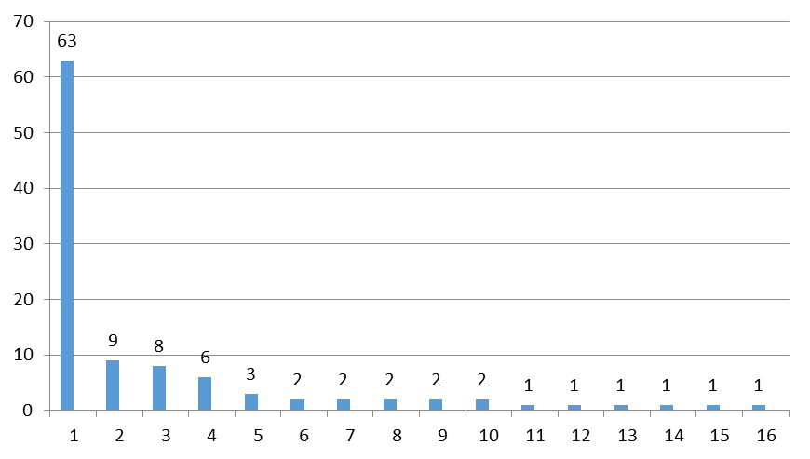
Chart 1 –Migrants women in the overall sample by country of origin (absolute numbers).
(Ukraine, Philippines, Slovakia, Moldova, Vietnam, Poland, Russia, Uganda, Algeria, Kyrgyzstan, Kazakhstan, Chechnya, Nigeria, Spain, Estonia, Tunisia)

The presented structure of migrant women (and a significant prevalence of migrants from Ukraine) is not really surprising as Ukraine has been the main source country for migration to the Czech Republic for a long time. Compared with the overall structure of migration in the Czech Republic, the representation of migrants from the Philippines differed in particular, due to the almost traditional specialisation of this country in “export“ of nurses, nannies and care workers. These women prevail in a live-in form of domestic work (see Chart 1).

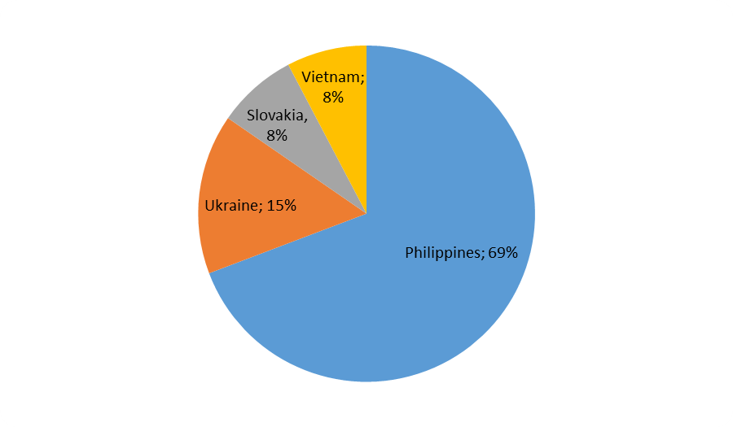
Chart 1 – “Live-in” respondents – country of origin (%)
Translation of the Chart: Ukraine 15.4%; Slovakia 7.7%; Vietnam 7.7%; Philippines 69.2%

Main differences between the most numerous group (Ukrainian migrants) and the group most typical for live-in activities are summarised in the table in Annex 11.4.
Our research shows high qualifications of migrant women – domestic workers – over 25% of the entire sample has tertiary education, the majority (over 65%) have completed a secondary school or have a similar type of education (see Chart 2). Over 91% of these migrant women have at least secondary education or its equivalent. In total, they represent labour force that in average is more educated than is usual for such positions in the Czech Republic; on the other hand, a rather high (formal) level of education raises a question whether the Czech Republic is able to provide adequate employment to these migrants. Researches (Ezzeddine, Kocourek, 2006; Gabal Consulting, 2006) have also shown that there is a gender differentiation in the methods of use of migrants’ qualifications. It is interesting that when judging the use of qualifications of both migrant men and women these analyses failed to prove differences in relation to the age and the length or type of stay (cf Bernard, Leontiyeva, 2012).

We have found out that migrant women´s language skills are very good. They either already speak Czech or they systematically learn it (73%), even though many of their employers are not of the Czech origin. Almost 82% of them speak yet another language than Czech or the main language in their country of origin; most frequently it is Russian, followed by English.

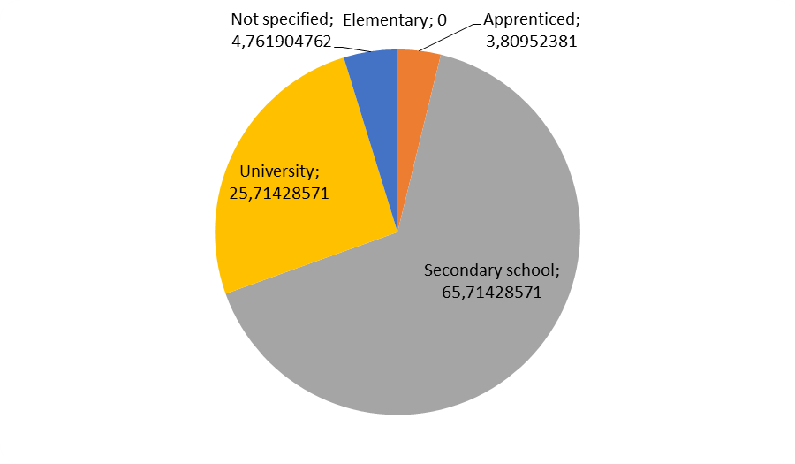
Chart 2 – Respondents by education (whole sample, %)

Translation of the Chart:
University 25.7; Not specified 4.8; Elementary 0.0; Apprenticed 3.8; Secondary school 65.7

Roughly 30% of all respondents are single, other 31.4% do not live with their original partner any more (see Chart 3 –Respondents’ family status ). There are also differences between the whole sample and the live-in group of migrants, as live-in migrants are predominantly unmarried.

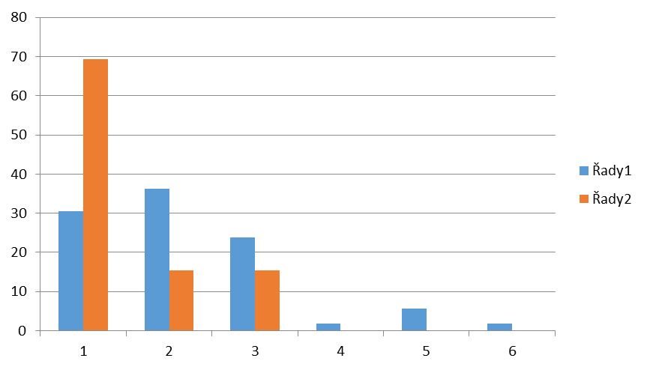
Chart 3 –Respondents’ family status (%)

Translation of the Chart:
All Live-in
Single; Married; Divorced; Married but not living with her husband; Widow; Not specified/not identified

Why and how did the migrants decide to come to the Czech Republic?
From the perspective of predicting the future development of this type of migration it is important to find out what made the migrants come to the Czech Republic and how they dealt with the arrival-related paperwork. Migrants decided to come to the Czech Republic on their own (47.6%) or after consultations with close family members (41%); none of them ended up in the Czech Republic against their will. These findings are also supported by gender-oriented theories about the migration-related decision making process, which place emphasis on independent decisions made by migrants, but at the same time they take into account broader structural conditions (including family background) under which individual agents make their decisions (Pedraza, 1991).
“Pull factors” (i. e. factors indicated by migrant women as important for the selection of destination of labour migration) included better financial conditions and the presence of family members and friends (see Chart 4). As argued by, e.g., Kosack (1991), access to paid work during migration may strengthen the gender force and status of migrant women in their own families. Some critics argue, however, that it may be only temporary (Pedraza, 1991).

Another area for concern may also be the fact that domestic workers’ income is very often associated with undignified working conditions (Uhde, 2012; Anderson, 2003).
Our research ascertained good preliminary awareness of advantages and disadvantages of the relocation to the Czech Republic, which at least partially explains relative satisfaction (and/or, as the case may be, a small proportion of complaints) with economic and other aspects of the stay in the Czech Republic.
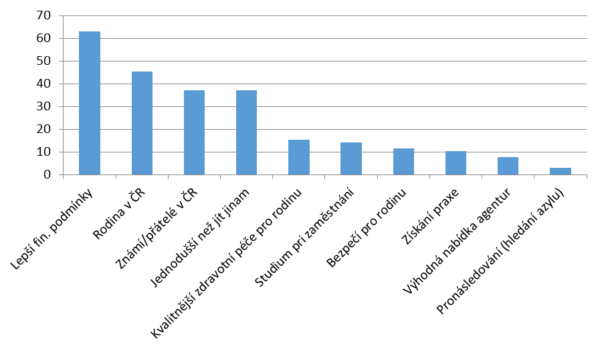
Chart 4 – Reasons for arrival to the Czech Republic (whole sample, %)

Translation of the Chart: Better financial conditions; Family in the CR; Acquaintances/friends in the CR; Easier than to go elsewhere; Better healthcare standard for the family; Extra-mural studies; Safety for the family; Gaining professional experience; Advantageous offer from agencies; Persecution (asylum seeking)

The situation of live-in migrants (mostly from the Philippines) is different. They usually get helped by job agencies when arranging for their stay and after their arrival, and therefore it is quite logical that fewer reasons associated with the existence of migration networks can be found. Strong and dominating motivation includes financial conditions (85%), more advantageous offers in general, and possibilities of gaining professional experience (see Chart 5).

The analysis of our research sample shows a marked role played by friends or family members (migrants’ networks) present during their arrival to the Czech Republic. With respect to live-out activities it is again friends and family members who help migrant women with the relocation and the related paperwork. Other reasons include less trust in agencies as well as bad experience the preceding migrants made with agencies. In absolute numbers – the services provided by agencies after migrants’ arrival to the Czech Republic were used by 12 respondents, of which 7 are still in contact with the agency and only five were satisfied with the services provided.
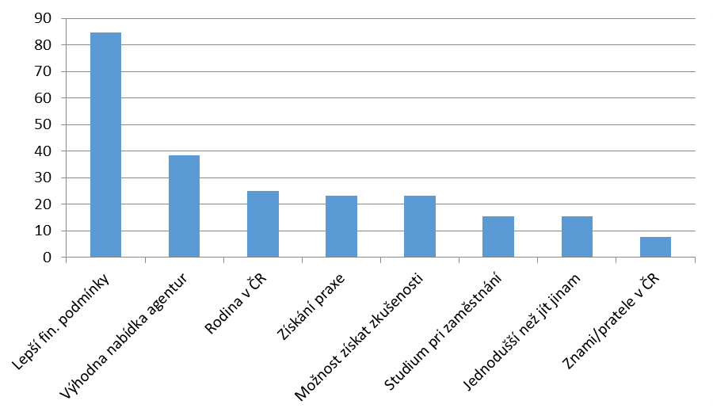
Chart 5 – Reasons for their arrial Důvody k příchodu do ČR (live-in %)

Translation of the Chart: Better financial conditions; Advantageous offer from agencies; Family in the CR; Obtaining professional experience; Possibility to acquire experience; Extra-mural studies; Easier than to go elsewhere; Acquaintances/friends in the CR

Migrants also tend to prolong their visa on an individual basis – of a total of 84 migrants who have to do so 69% claim to do it on their own. Only one third of those migrants, who used agency services for their arrival to the Czech Republic, rely on them if they want to prolong their visa.

Our research showed a greater involvement of migrant women in providing live-out services, prevailing activities being routine domestic cleaning work, window washing and ironing. Caring for children, preparing them for school and accompanying them to extra-curricular activities were also represented in our sample. An interesting finding was a rather low involvement (for example, compared to Germany and Austria) of migrant women in care for seniors and the sick, provided again as live-out services (Sekulová, 2013). A significantly increased involvement of migrant women is expected in this segment of domestic work in the upcoming years in relation to the ongoing ageing of the Czech population and development of services provided by the state.
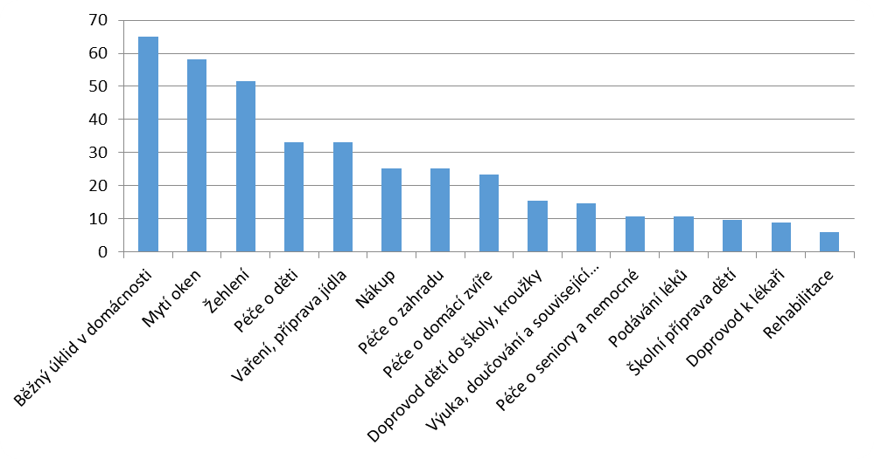
Chart 6 – Actual activities performed by migrant women (entire sample, %)

Translation of the Chart: Routine domestic cleaning work; Window washing; Ironing; Care for children; Cooking and meals preparation; Shopping; Care for a garden; Care for a pet; Accompaniment of children to school or extra-curricular activities; Teaching, tuition and related activities; Care for seniors and the sick; Administration of medications; Children´s school preparation; Accompaniment to doctor´s appointments; Physiotherapy

Types of employment relationships (work load) and remuneration
Our research also focused on the formalisation of employment relationships in the field of domestic work. However, the evaluation of results brought about difficulties associated with the existence of multiple concurrent employment relationships (for example, one legal employment and several side employment relationships), lack of respondents’ knowledge of differences between individual types of employment (e. g. agreement to complete a job, agreement to perform work, etc.). There were often more resulting combinations than the questionnaire could effectively distinguish.
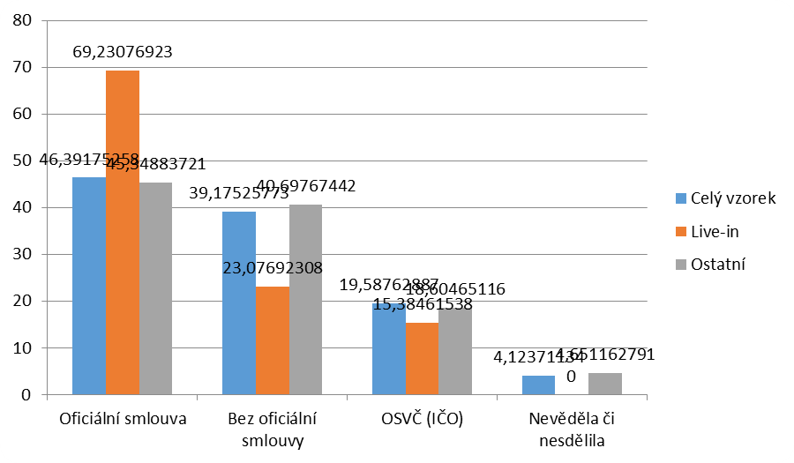
Chart 7 – Type of employment relationship (%)
Translation of the Chart:
Whole sample
Live-in
Other
Official contract; No official contract; Self-employed person (Company Registration Number); Not known or not provided

Generally speaking, far from all economic activities of migrant women are provided under a standard formal contract and subsequently properly taxed. More experienced migrants performing mainly cleaning work often prefer self-employment form, which provides them with greater independence. Of course, such form suits better also to their “employers” within “casualisation”. Over 39% of respondents stated that they worked without having any official agreement and/or, as the case may be, they did not know which form would best suit their situation. This high number (39%) cannot, however, be interpreted as saying that 39% of migrants work irregularly (thus not paying any taxes and insurance contributions).
However, it is also true that migrant women (at least in our sample) have at least some activities duly formalised (e. g., employment in a hotel, studies in the Czech Republic) and then they just “make a bit of money on the side” by performing cleaning work, taking care of children, etc., and it is this job on the side which is not underpinned by a formal contract. In some cases, the same also applies to self-employed persons (and not only from among migrant women).
The burden of taxation set, in particular, for low-income employees (tax abatement) and the possibility to legally restrict the payment of insurance contributions under an agreement to complete a job means that the difference in insurance contributions really paid by a migrant, who works legally for a low salary and officially earns some extra money under an agreement to complete a job, and a migrant who also has a legal employment contract and in addition, earns unofficially some extra money, for example, by performing cleaning work in the household of her employer without having any contract at all, may actually be rather small.
The absence of contractual coverage has two aspects – it is either performance of work for another entity (not always independent – for example, it happens quite frequently that a migrant performs cleaning work in the household of the owner of the company where she is legally employed), or performance of other activities not provided for in a contract. It also needs to be emphasised that in this particular field of activities informal employment is very common also for Czech citizens; and a similar situation can be found in other countries where activities such as babysitting, helping with cleaning work, etc. often fall within the unofficial economy. It cannot be automatically concluded that income tax or social insurance losses result purely from activities of migrants and their employers.

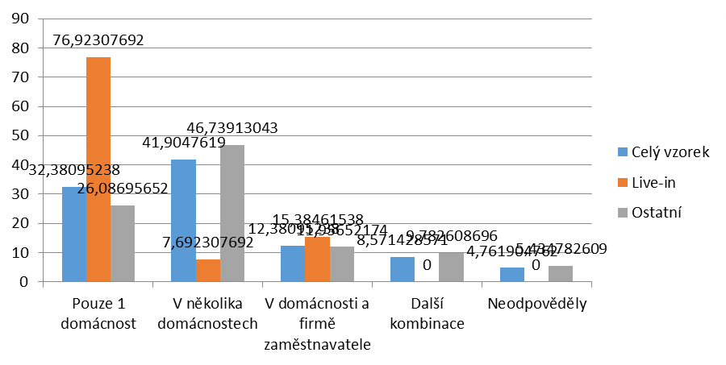
Chart 8 – Work performed in multiple locations / for more employers (%)
Translation of the Chart:
Whole sample
Live-in
Other
Only in 1 household; In several households; In the employer’s household and company; Other combinations; No answer provided

Live-in workers again do not fit into this model as their arrival to the Czech Republic is being arranged for by specialised agencies and therefore they more often have standard employment contracts – even though such contracts still do not cover all the activities.
Regarding forms of contracts common contracts for a definite period of time were represented most (typically for live-ins) followed by agreements to complete a job. The selection of an agreement to complete a job is not surprising, taking into consideration related administrative and financial benefits.
The role of an agreement to complete a job needs to be taken into account when analysing overtime work. Even though the limit of hours worked for one employer was already 300 hours/year at the time of data collection, in the past the limit was significantly lower, which led to a customary practice of underestimation of hours stipulated in the contract (and reported in related documents), and then to the generation of formal unpaid overtime, which in fact was not overtime at all.

Another similar factor that may result in “overtime work” is a condition that the work under an agreement to complete a job has to be remunerated with at least the minimal wage.

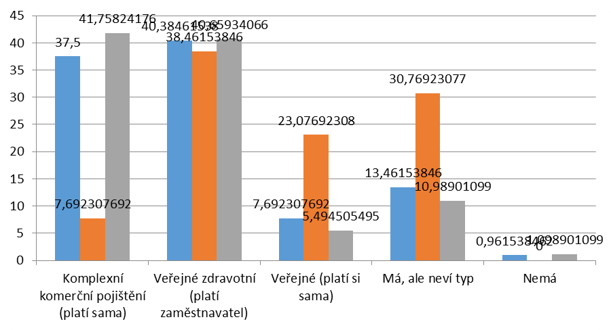
Chart 9 – Health insurance of migrant women (%)

Translation of the Chart:
Comprehensive commercial insurance (paid by her); Public health insurance (paid by the employer); Public insurance (paid by her); She has one but does not know what type; She does not have any

Irrespective of the existence and form of contract almost all migrants in our sample did have some form of health insurance – be it either a regular public health insurance (paid by their employer in the simultaneous employment relationship) or another type thereof. This finding is not in fact surprising because both male and migrant women are obliged to arrange for insurance in order to be able to get a residence permit. An interesting aspect is lower awareness of the type of insurance among live-in migrant women (almost 31% do not know the type of their insurance), which is likely to result from the fact that they quite often have official contracts (standard ones or negotiated by agencies) and thus they are more in a position of a regular employee.

Almost 74% of migrant women in the Czech Republic have already used some form of healthcare; ca 87% of them had no problems having the care covered from the existing insurance. Due to a high incidence of commercial insurance it is improbable that migrant women would present, in net numbers, additional costs for the Czech healthcare system. More disturbing is a high percentage of commercial insurance in this type of migrants – should they have a conventional health insurance instead, it would probably be economically more viable both for the migrants (commercial insurance comprises a number of exclusions) and for the Czech healthcare system.

Wage and forms of payment
Even though remuneration for the work done was covered in several questions of the questionnaire, due to the sensitivity of information and inaccurate information provided on salaries (net/gross/revenues of self-employed people) and related time specification, especially these results need to be considered as very approximate.
However, the data collected shows that migrant women most often work for ca EUR 3, 6 (per hour, after taxation). The median value for live-ins was ca EUR 3, 2 per hour, for the rest of the sample it was EUR 3, 6 per hour.
It does not seem to be an extremely low wage at first sight because the official gross hourly wage in the Czech Republic for the year 2014 is EUR 1, 84. The situation is, however, different if we take into account a high incidence of overtime hours (even though paid – see Chapter 6.1) as well as education of migrant women that is higher than usual for low-income employees in the Czech Republic. It can be therefore concluded that this type of migration is not, from the perspective of employers’ demand, motivated by attempts to go around minimum wage but the point is rather that the domestic labour force with similar reliability/qualifications would not be available for such price to sufficient extent.
It is interesting to learn that almost 63% of migrants are satisfied with their salaries, which may result from the following three factors:
- The vast majority of migrants come from the countries with significantly lower average salaries (Ukraine, Philippines, and Vietnam) and living standard (see Annex 12.2) or from higher-unemployment countries.
- For a number of live-ins it is a complementary employment.

- Salary is not the only benefit: a group of live-in migrants has, apart from salary, also accommodation, meals and air tickets paid. However, also other migrants (31 in total in the whole sample) stated that occasionally they also got some non-monetary performance in form of gifts, clothes, food or sweets. However, several female researchers (e. g., Rollins, 1985 and Anderson, 2008) highlight a risky nature of these “gifts” saying that they may establish a specific type of materialism, as workers may feel indebted to donors and subsequently they do not require remuneration for overtime work and are more flexible to employers’ requirements, etc.
With respect to the organisation of working activities it is not surprising to learn that almost 66.7% of migrant women are remunerated for their work at least partly in cash (9% of respondents mentioned concurrent remittances – in cash and to a financial institution in the Czech Republic); 31.4% of respondents get remunerated for the work done purely through remittances to their accounts with a financial institution. Only less than three per cent of respondents stated that they had funds sent also to accounts in another country; however, from comments made by several respondents it follows that this figure substantially underestimates the actual remittances.
Regarding the frequency of wage payments, there was, rather surprisingly, prevalence of respondents being paid once a month. Especially for live-in migrants it is the most common approach – their salary is agreed upon as monthly and is paid accordingly. Other migrant women most frequently (according to additional comments provided) fell under the following two categories – they were paid either immediately after the work done or they made use of multiple forms of payment (monthly payments with some employers, with others they were paid after the work done). The incidence of this scenario is lower than the percentage of migrants who mentioned cash payments, which indicates that both practical and tax reasons for this behaviour may prevail over the motivation associated with the enforcement of contracts.

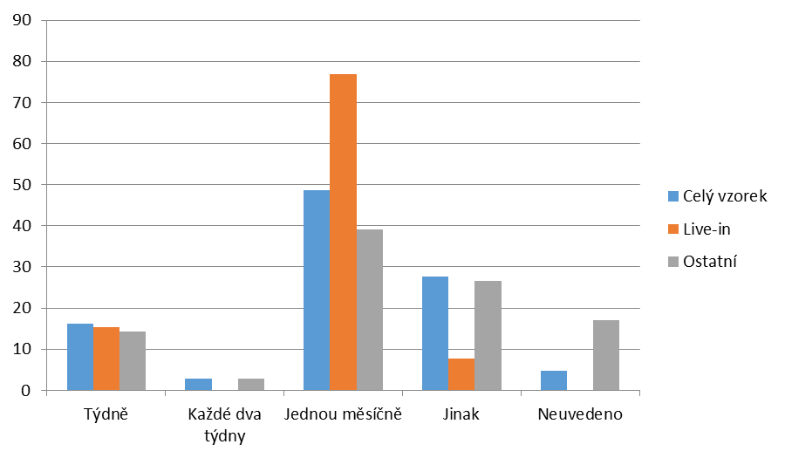
Chart 10 – Wage payment frequency (%)
Translation of the Chart:
Whole sample
Live-in
Others
Weekly; Bi-weekly; Monthly; Other; Not specified

Employing migrant women: role of other migrants
Our results show that the presence of other migrants in the Czech Republic played in migrant women’s activities yet another role than the basic motivation for their arrival to the Czech Republic (family/acquaintances) or acquiring information / help with formalities associated with their arrival. Migrant women were in fact often employed by families that entirely or partly (mixed families) came from abroad.
Questions concerning the nationality of their employers were answered by 94.3% of respondents, of which 27.6% worked for foreign employers, 21.9% for mixed families, 63.8% for Czech families (many migrants worked for more families and therefore the total number exceeds 100).

Even more striking are the results in live-in migrant women where 3 out of a total of 13 respondents work and live in Czech families, three work for foreign families and most of them (8) in mixed households, i. e. households where at least one partner comes from abroad.
Several respondents were not willing to name the country of origin of their employer. Partial results, however, show a rather significant diversification with a prevailing role of employers from the former Soviet Union (see Chart 11). This result is not overly surprising as the language knowledge of the migrants in our research is often a competitive edge for this type of employers.
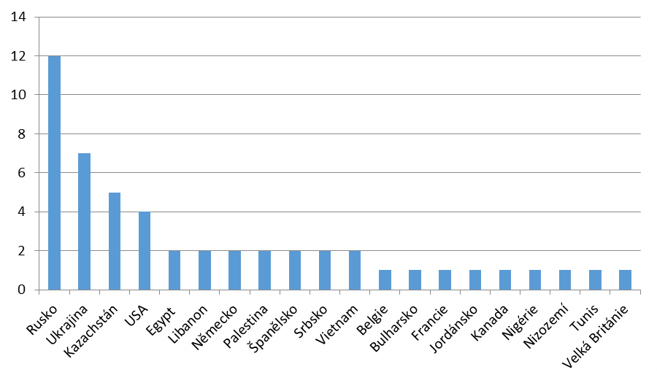
Chart 11 – Employers from abroad by country of origin (whole sample)

Translation of the Chart:
Russia, Ukraine, Kazakhstan, USA, Egypt, Lebanon, Germany, Palestine, Spain, Serbia, Vietnam, Belgium, Bulgaria, France, Jordan, Canada, Nigeria, Netherlands, Tunisia, Great Britain

However, employers come also from other countries (USA, EU). By performing the above activities the migrants help, among others, increase the attractiveness of the Czech market for foreign experts, managers and investors because they are able to offer assistance services such employees require due to their time-intensive workload (as well as lack of familiarisation with the Czech environment), or they are even used to them from previous stays in other countries or from their country of origin.

Life of migrant women domestic workers in the Czech Republic
In our research we decided to map out more extensively also other aspects of migrants’ activities in the Czech Republic, in particular problems they face, their family ties and their integration in local communities and/or communication channels that may be used to reach this target population.

Problems and their solution
With respect to the problems reported there are big differences between the live-in form and other migrants.
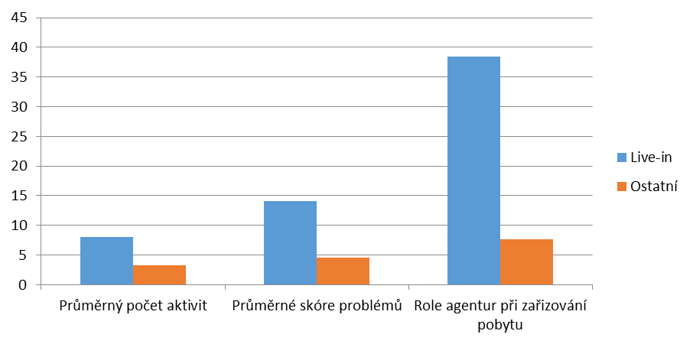
Chart 12 – Live-in versus others
Translation of the Chart:
Live-in
Others
Average number of activities; Average score of problems; Role of agencies in arranging for the stay

The live-in services are by nature very complex as they either intentionally or unintentionally include more types of activities (Chart 12). In addition, disagreements may occur between employers and migrant domestic workers due to a rather frequent direct contact in combination with greater cultural and language differences (the most of such migrants in our sample came from the Philippines). Our data shows, in particular, vaguely defined boundaries between the private life and work activities of migrants who live in the household they work for (tethnographic research of Filipino females in the Czech Rep. – Redlová, 2013 shows similar findings).

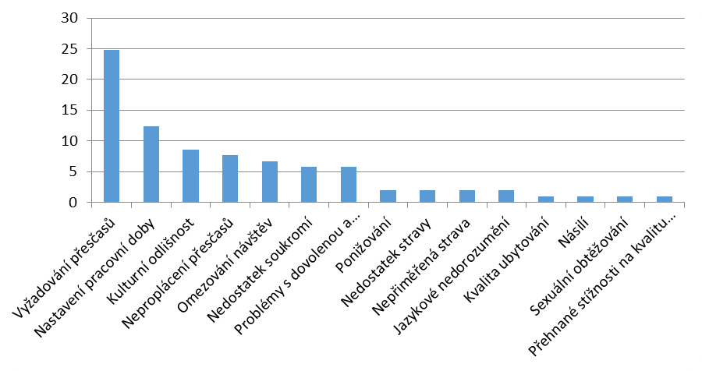
Chart 13 – Main problems faced by migrants (entire sample, %)

Translation of the Chart:
Overtime work required; Working time specification; Cultural differences; Unpaid overtime work; Restrictions imposed on visits; Lack of privacy; Problems with vacation and….; Humiliation; Lack of food; Inadequate food; Language misunderstandings; Accommodation quality; Violence; Sexual harassment; Excessive complaints about quality

More detailed results regarding the occurrence of specific problems are available in Annex 12.3, the overview of frequent issues are shown in Chart 134). The biggest issues (and conflicts) mentioned by our respondents were related to requests for and payment of overtime work, working time specification, cultural differences, excessive requirement for work quality and vacation and time-off-related issues.
Problems related to personal freedom restrictions, sexual harassment, passports being taken away from them and violence appear in our sample only in an extreme situation. Having said this we do not claim that similar situations cannot occur in the Czech Republic. Problems related to cultural differences and more frequent direct contacts (including, for example, lack of privacy) were more often mentioned by the live-ins.

The research also showed that migrants with a more stable residence situation (permanent residence) and with the related language and socio-cultural knowledge of the receiving society as well as self-employed migrant domestic workers have a more secure work position in terms of potential problems.
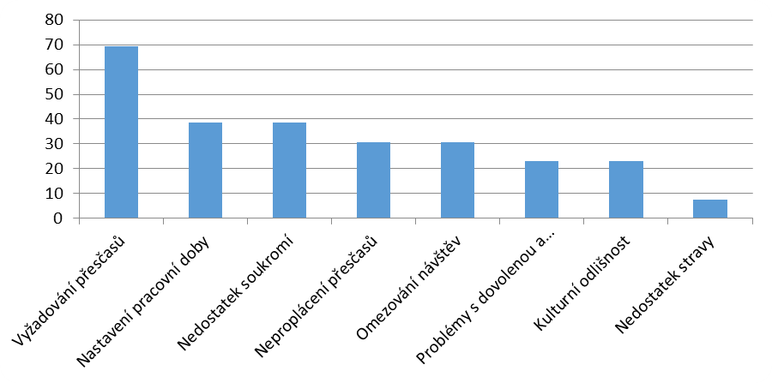
Chart 14 – Main problems faced by migrants (live-ins, %)
Translation of the Chart:
Overtime work required; Working time specification; Lack of privacy; Unpaid overtime work; Restrictions imposed on visits; Problems with vacation and….; Cultural differences; Lack of food

Overtime-related problems showed a bit different aspects than expected. The point is not so much the unpaid overtime work (over 78% of respondents were paid for the overtime work, ca 7% stated that they were paid for overtime work at least occasionally or they received some bonus in return), but rather the definition of overtime work and time intensity required. In particular, in live-in services it happens that migrants have an official employment contract for 40 hours a week but in fact they are available in the household for 14 – 16 hours a day and they also perform other auxiliary activities without employers considering them overtime work.

Dealing with problems and migrants’ awareness
Migrants involved in our research were quite well informed of services and assistance provided by the state and, in particular, by non-profit organizations. However, it needs to be emphasised that it is impossible to automatically conclude only from this data that there is a better awareness of non-profit organizations than it is of organisations established by the state (Centres for the Support of Integration of Foreigners) throughout the population – the method of selecting and contacting the migrants increased likelihood that women who have experience with NGOs would be more represented among the respondents.
Migrant women made mostly use of the following services provided by non-profit organizations: legal counselling, accompaniment to and interpretation services at immigration police and Czech language courses. The group of the Filipino migrants was positive about assistance provided by the Representative Office of the Republic of the Philippines in Prague.
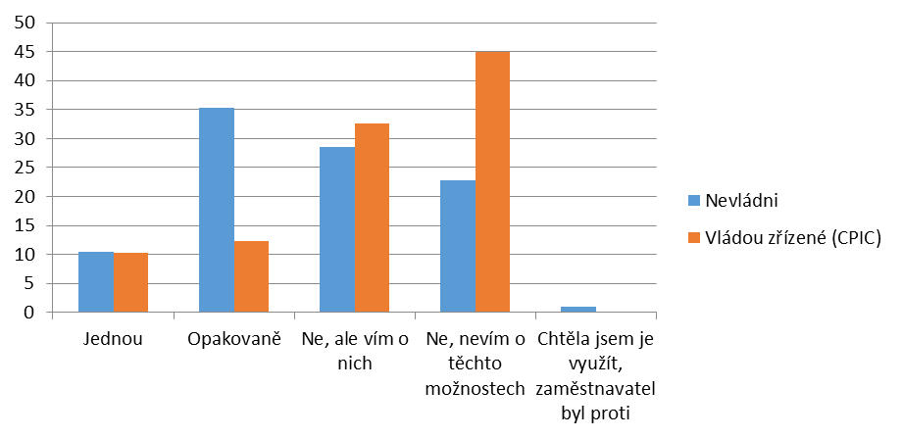
Chart 15 – Migrants and use of official and nongovernmental assistance services (%, whole sample)

Translation of the Chart:
Nongovernmental
Controlled by the state (Centres for the Support of Integration of Foreigners)
Once; Repeatedly; No, but I know about them; No, I do not know about such possibilities; I wanted to use them but the employer did not agree

It is not overly surprising that the strong role of the existing ties (family, friends and acquaintances) is also present when learning about the existence of assistance services. The second most important role is played by the internet and some respondents established contacts also through agencies.
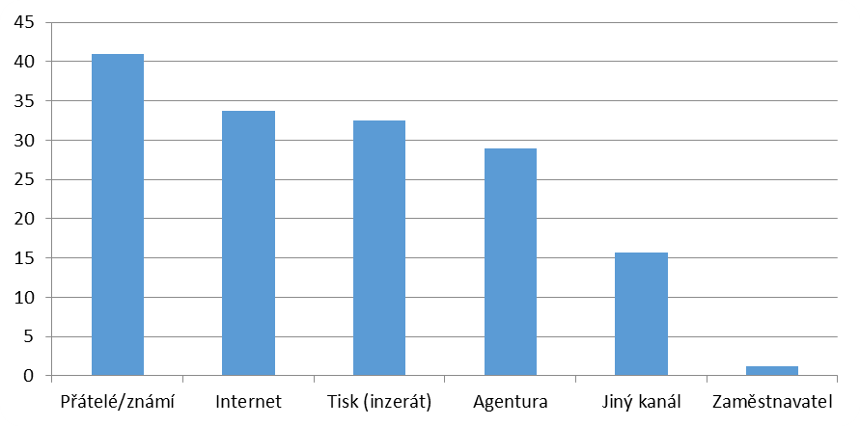
Chart 16 – How did the respondents learn about assistance services? (whole sample, %)

Translation of the Chart:
Friends/acquaintances; Internet; Press (advertisements); Agency; Another channel; Employer

If the migrants had to deal with specific problems with employers they mostly tried to do so on their own, which is explained by the private nature of domestic work performed in absence of the public or other employees, as well as by the unofficial nature of a number of working activities. The use of agencies or non-profit organizations s is less frequent in our sample of migrants (and/or it is probably limited to more serious problems) – see Chart 17).

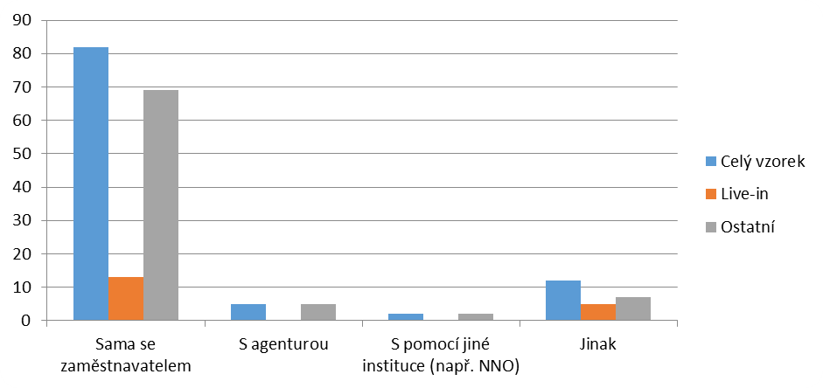
Chart 17 – Who migrants discuss their problems with (number of answers)

Translation of the Chart:
Whole sample
Live-in
Others
On her own with the employer; With an agency; With the help of another institution (for example NGO); Otherwise

A specific form of dealing with problems was “adaptation” – i.e. an attempt to get used to a different environment, culture and eating habits – was mentioned by live-in migrants in their comments.

Transnational family relationships: children, parents and mutual communication
The presence of family in the migration situation is, in particular for women, very important. To a great extent it influences their decision-making strategy for permanent form of migration – i. e. whether the migrants stay (and how long) in the migration location. Separation from their families is usually more difficult for women who migrate on their own and/or, as the case may be, do not have a male partner in the migration or are divorced (Aranda, 2003).

In the labour migration of migrant women – transnational mothers - experience spatial, time-related and emotional separation from their own children. At the same time they are responsible for feeding their nuclear and extended families. In relation to this Sotelo states the following (Sotelo, 2001:16): “Transnational mothers bring about a new quality aspect of motherhood, new inequalities and new meanings of family.” In our sample over 94% of migrants had some form of family ties in their country of origin. Most frequently these were parents (almost 66%), children (33%), and grandparents (28.6%) – see Chart 18. Migrants women most frequently have at least one child (65%), and paradoxical situations may occur when mothers earn money in the Czech Republic by caring for children of their employers in order to use these funds for financing substitution care for her own children – it is called “global care chains” (Hochschild, 2008). However, Rothman (1989:43) highlights the specific nature of the domestic work (especially the one associated with care) when stating that: “When such work is carried out by mothers it is called motherhood..., if performed by paid labour it is called unqualified work.”
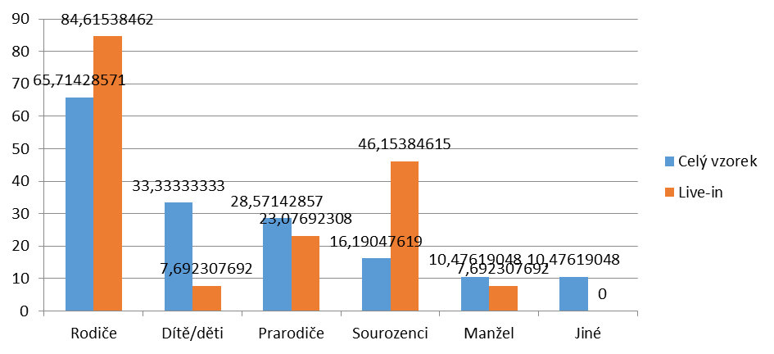
Chart 18 – Family ties of migrants in their countries of origin (%)

Translation of the Chart:
Whole sample
Live-in
Parents; Child/children; Grandparents; Siblings; Husband; Other

Our sample specifically included 51% of mothers who have children (even though in some cases grown-ups) in their countries of origin, of which 71% wanted to bring their children to the Czech Republic.

The high proportion of migrants with children in the country of origin is not surprising, mainly as far as migrants from Ukraine are concerned, of which 41.3% had children in their country of origin. Researches of the family structure of migrant men and women (e. g., Gabal Consulting, 2007) show that migrants from Ukraine account for the most numerous group of transnational parents living and working in the Czech Republic.
The reason for a high number of transnational mothers is not only the geographical distance between the Czech Republic and Ukraine, but also the possibility of the ”circular migration“, which makes it possible for the migrants to better coordinate their reproduction and production activities. The existence of transnational families is, however, strengthened, in particular, by non-conceptual integration policy of the Czech Republic (Ezzeddine, 2011).
The most frequently stated reason why their children did not live together with them was a complicated legalisation of children’s stay in the Czech Republic (18 respondents) and the decision of their adolescent children (also 18 migrants), economic reasons (lack of money, 16 respondents) ranked the third, followed by the fact that they would not have time to care for their children due to excessive time intensity of the work.
Migrants try to solve this problem by frequent communication with their families. Of those who stated that they had some ties in their countries of origin (101) 28.7% of migrants communicated with their families every day, other 38.6% of migrants at least once a week. 2.9% of migrants communicate with their families less than once a month. Our research confirmed the growing role of modern technologies when maintaining transnational social relations (Lutz, Palenga-Möllenbeck, 2009). In many cases it is still the telephone that is used for communication but in general, internet communication channels (email, chat/facebook, communication through Skype) have a still more important role to play. Written communication (letters) plays a marginal role in general (see Chart 19). Especially those migrant women who communicate with their families on a daily basis rely mainly on Skype (96.6 %).
The separation between migrants and their families relates to the economic reality of migration. As argued by Parreñas (2001), the receiving states profit not only from the cheap labour of both migrant men and women, but mainly from their minimized needs. With their migration policies they in fact promote individual circular migration in low-income families because they do not have to assume responsibility for their reproduction. According to Parreñas (2001) the globalisation causes that these transnational mothers live parallel lives, which further intensifies such globalisation.

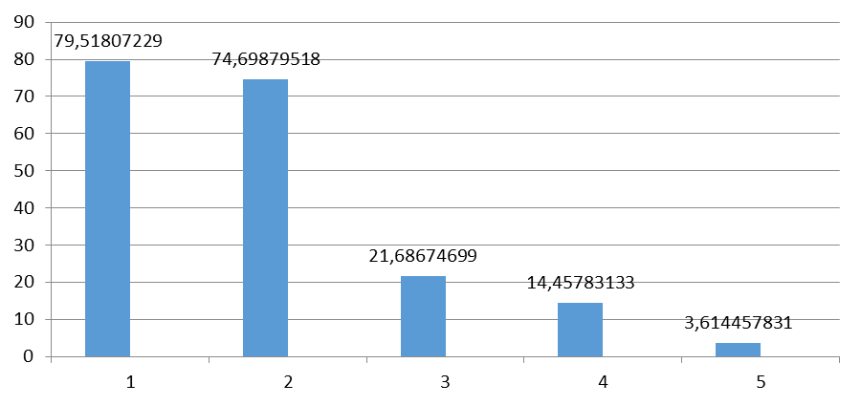
Chart 19 – Forms of communication with proper families (whole sample, %)
Translation of the Chart:
Telephone 79.5; Internet (Skype) 74.7; Internet (email) 21.7; Internet (chat) 14.5; Letters 3.6

Inclusion in the Czech environment: who do migrant women domestic workers meet and communicate with?
The migrants included in the research try, in spite of lack of time, to have some social life in the Czech Republic. All of 97 respondents who answered this question actively strived to have some social activities and none was prevented therefrom by their employers (see Chart 20).
An important role is played by regular or occasional meetings with expats (altogether almost 88%); also the percentage of occasional and regular attendances at religious services (almost 61%) was quite significant for the Czech environment. The support of expat social networks at the beginning and in the course of migration confirms the importance of networks mentioned by Massey et al. (1993) as helping to reduce both the migration-related costs and risk. Social networks may also have an important function in the “survival strategy“. They function as an emotional support system, in particular the networks of relatives and friends do (Aranda, 2003). They satisfy emotional needs of migrant men and women and provide help and support. It is the migrant women who are even more sensitive to the absence of their families, especially in crisis situations such as divorce, birth of a child or death in the family. On the other hand – researches by Boyd and Grieco (1998) showed that the size of family and related networks did not turn out to be statistically significant factors influencing either temporary or permanent migration.

The fact that a very high percentage of respondents have local friends in the Czech Republic and are in regular contact with the local population is considered positive. This together with a relatively high education of migrants and the fact that they either already know the Czech language or learn it systematically (73 %) indicates that there is no risk of occurrence of problems which, due to exclusion of migrants, occur in some traditional target countries. A relatively high percentage of visits at individual events (concerts, theatre performances, etc.) were rather interesting.

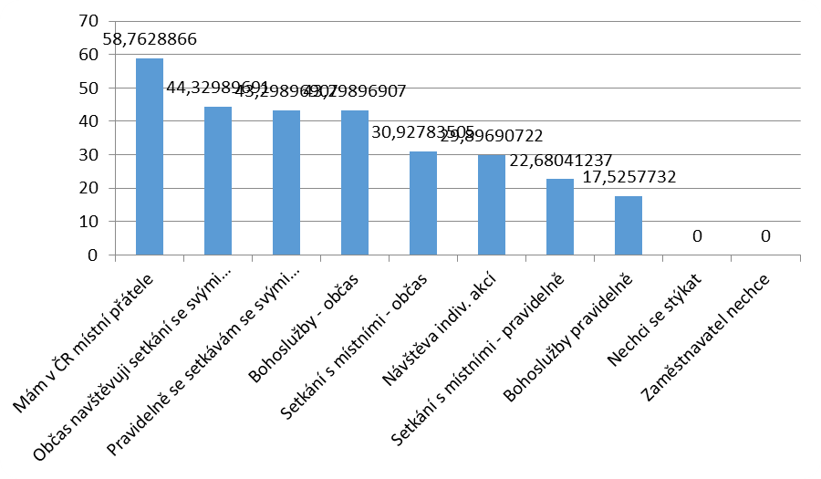
Chart 20 – Which of the following statements would best describe your social life in the Czech Republic? (whole sample, %)
Translation of the Chart:
I have friends among local people in the Czech Republic; I occasionally attend expat meetings; I regularly meet with my compatriots; Religious services – occasionally; Meeting local people – occasionally; Visiting individual events; Meeting with locals – regularly; Religious services – regularly; I avoid encounters; The employer doesn’t want me to do it

Economic impacts of care migration on the Czech Republic
The research results indicate that this type of migration (migration of domestic workers) does not present a significant economic or security problem; on the contrary, it is a phenomenon which helps to reduce certain structural problems (weakening of a welfare state) and weaknesses of the Czech economy.
It is clearly positive that such type of migration complements or even substitutes the care which, because of lack of funds or administrative inflexibility, is insufficiently provided by the state/public sector (care for young children or seniors). This type of migration thus indirectly enables to save the costs which would otherwise have to be funded from public budgets. Another great benefit is the fact that these are services that the traditional Czech society considers to be female activities within the confines of family. A possibility to hire an external assistance thus helps solving the problems and losses caused by lack of involvement of younger women (especially mothers with young children) in the Czech labour market (Křížková et al., 2008).
We cannot deny that the unofficial character of a number of migrants’ activities may also have negative impacts in form of lower collection of taxes/insurance contributions or ousting of Czech employees. However, the research results do not seem to show that these impacts would in reality play a significant role.
- Tax losses, if any, are rather improbable – due to low remuneration and, in particular, due to the work nature and organisation (even with “domestic” employees the tax collection would not be probably better).
- The ousting of Czech employees from the labour market is not very likely either. Migrant women work in positions that Czech unemployed people are not interested in or do not have sufficient qualifications for (care for the sick, language teaching).
- Increased cost for the health insurance system (without corresponding increase of income) is unlikely, too – the vast majority of migrants do pay some type of health insurance – either as part of another legitimate employment, or they have an additional private insurance cover (over 99% of respondents in total). Therefore, it is more about a redistribution of profits between insurers who provide additional commercial insurance and the funds which are actually spent in the healthcare sector.

Proposal of analytical classification of migrant women working in Czech families
Using the data from the questionnaires, we have attempted to classify the migrants whom we have met throughout the course of the study. The classification is based on three main factors that can be used to describe and classify the situations and problems that migrant women are facing. Importantly, this classification and categories included are not exhaustive as it leaves out cases not present in the study (such as migrant women from developed countries outside the EU)

- Classification based on accommodation and reliance on one employer:
- Migrant women living directly in a family (live-in). Typically, these migrants offer a highly professional home care services (especially for Filipino workers this constitutes an intentional career choice). Due to almost constant presence in the family, the typical problems is overtime and its definition, growing demands on performance of the worker and problems arising from almost constant personal contact. As for organisation, these migrants usually have one employer and work under an official contract. The perceived dependence on this employer may lead to a tendency to adjust to new realities instead of dealing with problems.

- Migrant woman coming to work in the families (live-out). Independently living migrants often work for more than one employer and specialize in fewer activities (such as cleaning services for a number of households). Greater independence and less intense personal contact helps to avoid certain problems (definition of overtime, conflicts arising from cultural differences) and migrants can also change their employer in an easier way.

- Classification based on intention to work in this segment of the labour market:
- Ad hoc employment. In this category, there are asylum-seekers, spouses and students who have come to the Czech Republic for other than economic reasons and are now looking for an extra income. The employment is seen as temporary or secondary in importance and the migrant might not be dependent on it economically or in order to legalize her stay in the country. Similarly to analogous jobs of Czech citizens, this secondary character of employment is then demonstrated by informality of contracts (spoken agreements on cleaning services, cash payments).

- “Full-time unprofessional home care workers.” The main employment of these migrants is based on their intention to come to the Czech Republic that is motivated by a desire to improve their life situation. The migrants have knowledge on the workings of the market through friends or relatives, but this type of the employment is chosen more or less out of necessity. These are usually migrants who are following their families or who had problems finding employment in the original labour market in their country. Their coming to the Czech Republic was therefore economically motivated, but the migrants are often more qualified than necessary for this type of employment and are often working in another field than they used to in their country of origin. They are more dependent on their employment than the first group and handle problems often with help or experience of their relatives or friends. In attempt to become self-realized and as independent as they were in their previous jobs, these migrants often move to entrepreneurship (for example becoming a self-employed worker offering cleaning services).

- “Full-time professional home care workers”. Migrant women from the Philippines constitute a specific category as they have systematically prepared for the career of a carer and took up this employment in the Czech Republic. Nevertheless, they may sometimes be forced to occupy themselves with activities beyond their main task and beyond their qualification. On one hand, their position is weaker due to their higher dependence on one employer and less thorough knowledge of local environment. On the other hand, their stay in the Czech Republic is usually provided for by official contracts and they have the option of seeking help of the agencies that have arranged their stay when facing problems. This category more or less overlaps with the live-in category from the previous type of classification. In is important to note, however, that this live-in service is only a temporary employment for some qualified carers for elderly people (usually women from Ukraine) because of its physical and psychological demands and because of problems with verification of previous education and qualification. The goal of those workers is then usually a formal professionalization and work in Czech medical facilities (Ezzeddine, 2012).

- Classification based on country of origin and closeness of language
- Migrants – home care workers from EU countries. This group has legal rights to stay, do business or look for employment without greater restrictions and the women come from countries that are relatively stable and developed. Both of these factors make the group far less vulnerable. Migrants from Slovakia constitute a distinct subgroup as they are perceived by many employers practically as “domestic” labour force and therefore without the danger of administrative or cultural problems. Migrants – home care workers from the former Eastern Bloc outside the EU.

These women come from less developed and poorer countries and are often very dependent on their current pay. They have more disadvantages than the first group when entering the labour market because of formal immigration policy and also because their countries of origin and fellow countrymen are often perceived by Czech people as causing problems and troubles. An advantage for them is the familiarity of the environment (the Czech Republic and their country of origin), closeness of language and often also network of friends and relatives in the Czech Republic. A combination of these factors causes these migrants to be very likely to become illegal workers and often to be unable to prevent negative occurrences on this job market.

- Migrants – home care workers from other less developed countries. These migrants are highly disadvantaged on Czech labour market because of the immigration policy and because of the difficulty of language and cultural barrier. Therefore, they usually form the category B.1 (ad hoc employment in the form of helping other women from their community) or B.3 (professional migration).

Summary and recommendations
This research study is the first attempt to empirically map the activities of foreign home care female workers in Czech homes. One of the contribution of the study is therefore also methodological – we have identified and tested the ways to approach the communities and this can easily be used in possible future studies or information campaigns. The study also offered a basic classification of migrants and stated the level of their vulnerability towards the risks coming from working in unofficial home care labour market.
An important finding of the study is the fact that the migrants coming to the Czech Republic are usually at least formally qualified for their jobs, something that is not typical for the rest of the workers in the field. It was positive that among this study’s respondents there were no cases of extreme behaviour from employers that are known from other countries.
The main factor determining migrant’s choice to come to the Czech Republic was better wages but also presence of friends or relatives. These networks of migrants work also as information sources and partly also as substitutes for institutions helping the migrants with necessary formalities.
Migrants employed in Czech families do not constitute a burden to Czech economy, on contrary, they help to lessen its problems: population ageing, growing expenses on healthcare and social services, danger of lack of medical staff, insufficient nursery capacities and (women) employment. If the Czech Republic wishes to explore these advantages, it should nevertheless prepare itself more and make use of and rightly assess the qualification of the migrants.
This study has shown that working and living conditions for migrants could be improved by stable residence status, formalization of working conditions and restrictions (simplification of procedures), possibility to enter public healthcare sector and simplification of migration for family members. These improved conditions would then attract more migration of the type that is beneficial to the Czech Republic.

Bibliography
ABRANTES, M. (2014): Yes, but what about numbers? A quantitative contribution to the study of domestic services in Europe, International labour review, 153 (2):223-245.
ANDERSON, B. (2002): Just Another Job? The Commodification of Domestic Labor, s. 104-114, In: Global Woman – Nannies, Maids and Sex Workers in the New Economy. New York: Granta Publications.
ARANDA, E. M. (2003): Care work and gendered constraints: The Case of Puerto Rican Transmigrants. Gender and Society 17 (4): 609-626.
BARBER, P. G. (2000): Agency in Philippine women’s labour migration and provisional diaspora. Women’s Studies International Forum 23(4), s. 399-411.
BERNARD, J.;LEONTIYEVA Y. (2013): Cizinci jako obtížně dosažitelná populace. Data a výzkum – SDA Info 7 (1): 57-82, http://dx.doi.org/10.13060/1802-8152.2013.7.1.3
BOYD, M.; GRIECO, E. (2003): Women and migration: Incorporating gender into international migration theory. Migration Policy Institute.
BRETTEL, C.B. (2000): Theorizing Migration in Anthropology: The Social Construction of Networks, Identities, Communities, and Globalscapes, s. 113-161, In: Brettel C., Hollifield J. (eds.), Migration Theory: Talking Across Disciplines, New York: Routledge.
ČSÚ: Cizinci v ČR 2013. ČSÚ, 2013.
EHRENREICH, B.; HOCHSCHILD, A. R. et al. (2002): Global Woman – Nannies, Maids and Sex Workers in the New Economy. New York: Granta Publications.
ENGLAND, P. (2005): Emerging Theories of Care Work. Annual Review of Sociology (31): s. 381–399.
EZZEDDINE P.; KOCOUREK, J. (2007) : Internal Restriction on Czech Labour Market (research report), IOM Prague/ Global Development Network.
EZZEDDINE P. (2011): Neviditelné ženy (analýza genderové perspektivy integrační politiky ČR), s. 113-123, In: Knotková, B. a kol. Mezi Obzory. Gender v interdisciplinární perspektivě. Praha: Gender Studies, o.p.s.
EZZEDDINE, P. (2012): Mateřství na dálku: transnacionální mateřství ukrajinských migrantek v České republice. Gender-rovné příležitosti-výzkum (13) 1, s. 24–33.
EZZEDDINE, P. 2012. Stáří, péče a migrace,s. 55-64, In: Ed. HORNOVÁ M.: Pečuj a vypečeme Tě: zpráva o neplacené práci v ČR. Praha: Gender Studies o.p.s.
FUDGE, J. (2011): Global Care Chains, Employment Agencies, and the Conundrum of Jurisdiction: Decent Work for Domestic Workers in Canada. Canadian Journal of Women and the Law 23 (14), s. 235-264.
GABAL CONSULTING (2007): Analýza přístupu migrantů a migrantek na trh práce a vzdělávání v ČR (výzkumní zpráva). Praha.
GODIN M. (2013): Domestic work in Belgium:Crossing Boundaries between Informality and Formality, s. 17-43, In: Ed. Triandafyllidou A.: Irregular Migrant Domestic Workers in Europe.Who Cares?, Aldershot: Ashgate.

GORODZEISKY, A. ; SEMYONOV, M. (2014): Making a living in two labor markets: Earnings of Filipinos in the global and the domestic economy. Research in Social Stratification and Mobility 37(9): s. 77–89.
HNILICOVÁ, H. a kol. (2012): Analýza komerčního pojištění cizinců. Prezentováno na Výboru pro práva cizinců, 17. října 2012.
hOCHschild, A. (2008): Láska a zlato. Globální řetězce péče, s. 107–128, In: Hrubec M. a kol. Sociální kritika v éře globalizace. Odstraňování sociálně-ekonomických nerovností a konfliktů. Praha: Filosofia.
KŘÍŽKOVÁ A. a kol.(2008): Práce a péče. Proměny "rodičovské" v České republice a kontext rodinné politiky Evropské unie. Praha: SLON.
LUTZ, H.; PALENGA-MÖLLENBECK, E. (2009): „The „care chain“ concept under scrutiny.“ Příspěvek na konferenci Care and Migration, 23.- 24. 4. 2009, Goethe University, Frankfurt nad Mohanem
LUTZ, H. (2011): The New Maids. London: Zed Books.
PARREŇAS, R. S. (2000): Migrant Filipina Domestic Workers and the International Division of Reproductive Labor. Gender & Society 14 (1), s. 260–281.
MAN, G. (2004): Gender, work and migration: Deskilling Chinese immigrant women in Canada. Women’s Studies International Forum 27, s. 135– 148.
MASSELINK, L.E.; LEE S.-I. D. (2010): Nurses, Inc.: Expansion and commercialization of nursing education in the Philippines. Social Science & Medicine (71): s.166-172.
MASSEY, D. et al. (1993): An Evaluation of Migration Theory: The North American Case, Population and Development Review (20): 699-751.
PARREÑAS, R. S. (2002): The Care Crisis in the Philippines – Children and Transnational Families in the New Global Economy, s. 39-54. In: Global Woman – Nannies, Maids and Sex Workers in the New Economy. New York: Granta Publications.
PARREÑAS, R. S. (2012): The Reproductive Labour of Migrant Workers. Global Networks 12 (2): s. 269–275.
PEDRAZA, S. (1991): Women and migration: The social consequences of gender. Annual Review of Sociology (17): s. 303-325.
RAGHURAM, P.; KOFMAN, E. (2004): Out of Asia: Skilling, re-skilling and deskilling of female migrants Women’s Studies International Forum 27 (2004): s. 95-100.
REDLOVÁ, P (2012): Chůvou od narození? Reprezentace filipínských hospodyň prostřednictvím agentur práce a médií v Česku, s. 65-76, In: Ed. Hornová, M.: Pečuj a vypečeme tě: zpráva o neplacené práci v ČR. Praha: Gender Studies.
REDLOVÁ, P. (2013): Employment of Filipinas as Nannies in the Context of Post-Socialist Czech Republic. Lidé města/Urban People 15 (2): s. 185-217.
ROLLINS, J. (1985): Between Woman: Domestics and their Empoyers. Philadelphia: Temple University Press.
ROTHMAN, K.B. (1994) : Recreating Motherhood, New Brunswick: Ruthger University Press.
SOTELO, P. H. (2001): Doméstica. University of California Pres: Berkeley.
SOURALOVÁ, A. (2010): Feministická reflexe migrace: pečovatelky, zdravotní sestry a globalizovaná migrace. Gender, rovné příležitosti, výzkum 11 (1), s. 41-48.

SEKULOVÁ, M. (2013): Transnational Households in the Context of Female Migration from Slovakia to Austria. Lidé Města / Urban People 15 (2), s. 217-237.
UHDE, Z. (2009): K feministickému pojetí péče jako kritické kategorie sociální nerovnosti. Sociologický časopis 45 (1), s. 9–29.
UHDE, Z. (2012): Slepá ulička instituce nájemní domácí péče. Gender, rovné příležitosti, výzkum 13 (1), s. 12–23.
VAN WALSUM, S. (2011): Regulating Migrant Domestic Work in the Netherlands: Opportunities and Pitfalls. Canadian Journal of Women and the Law/Revue Femmes et Droit, 23(1), s. 141-165.
YANG, D.; MARTINEZ C. A. (2005): Remittances and Poverty in Migrants’ Home Areas: Evidence from the Philippines, Working Paper, University of Michigan.
YEOH, B. S. A.; HUANG, S., GONZALEZ J. (1999): Migrant Female Domestic Workers: Debating the Economic, Social and Political Impacts in Singapore. International Migration Review 33(1): s. 114-136.

Authors

Mgr. Petra Ezzeddine, Ph.D.
is a social anthropologist and a lecturer at both the Department of General Anthropology and the Department of Gender Studies at the Faculty of Humanities, Charles University, Prague. Her research focuses on gender issues in migration, transnational motherhood, and transnational networks of child care and senior care. She has completed several internships abroad - e.g. at the Hebrew University of Jerusalem and the Goethe University in Frankfurt. She is a member of the editorial board of the Journal of Human Affairs: Post-disciplinary Humanities & Social Sciences Quarterly and www.migraceonline.cz. She cooperates with Czech and Slovak non-profit organizations that focus on migration and inclusive education.

Vilém Semerák, Ph.D.
is an economist who deals with the issues of economic transformation, China's reforms
and international trade. He graduated from the University of Economics, Prague, and the Institute of Economic Studies at the Faculty of Social Sciences, Charles University (IES FSV UK), Prague. He completed a study internship at London School of Economics and Political Science. In the period 2004-2005, he lectured at Shandong Economic University (SEU), China, and in the years following, he completed several research stays in Shanghai and Beijing. He currently works as a researcher for the IDEA think-tank at CERGE-EI and IES FSV UK, and teaches at London Metropolitan University. He is also a member of the advisory board of the research advisory group of OMFIF.

Charts and attachments

Total number of respondents who filled out a majority of the questionnaire
Country of origin | Number of respondents | % of sample
Ukraine | 63 | 60.0
Philippines | 9 | 8.6
Slovakia | 8 | 7.6
Moldavia | 6 | 5.7
Vietnam | 3 | 2.9
Poland | 2 | 1.9
Russia | 2 | 1.9
Uganda | 2 | 1.9
Algeria | 2 | 1.9
Kyrgyzstan | 2 | 1.9
Kazakhstan | 1 | 1.0
Chechnya | 1 | 1.0
Nigeria | 1 | 1.0
Spain | 1 | 1.0
Estonia | 1 | 1.0
Tunisia | 1 | 1.0
Table 1 – Respondents according to the country of origin

Comparison of migrant’s countries and the Czech Republic
Using data from 2013.
Country | GDP per capita (PPP, CZ = 100) | GDP per capita (common prices, CZ = 100) | Unemployment level (%)
Spain | 109.7 | 154.6 | 26.4
CZ | 100.0 | 100.0 | 7.0
Slovakia | 90.5 | 93.9 | 14.2
Estonia | 85.1 | 100.9 | 8.6
Poland | 78.0 | 71.0 | 10.3
Russia | 65.8 | 78.6 | 5.5
Kazakhstan | 52.9 | 68.1 | 5.2
Tunisia* | 36.5 | 23.0 | 16.7
Algeria* | 27.7 | 28.8 | 9.8
Ukraine | 27.3 | 20.8 | 7.4
Philippines | 17.2 | 14.8 | 7.1
Vietnam | 14.7 | 10.1 | 4.4
Moldavia | 13.7 | 11.8 | 5.2
Nigeria* | 10.4 | 9.0 | n/a
Kyrgyzstan | 9.6 | 6.8 | 7.6
Uganda | 5.5 | 3.3 | n/a
* Only 2013 estimate available
Used abbreviations:
GDP – gross domestic product
PPP – purchasing power parity

Source: MMF, World Economic Outlook Database (April 2014).

Answers to the question: What were the problems you encountered while working at your employer’s home? (Question 36)

Whole sample used, the numbers designate the percentage of number of respondents.
 | Unpaid overtime | Overtime demanded | Determined working hours | Unpaid salaries | Compensation for damaged possessions demanded | Humiliation | Lack of privacy | Accommodation quality | Lack of food
Without answer | 21.0 | 19.0 | 22.9 | 25.7 | 24.8 | 24.8 | 25.7 | 26.7 | 25.7
Never | 52.4 | 35.2 | 41.9 | 63.8 | 70.5 | 66.7 | 64.8 | 67.6 | 70.5
Once | 2.9 | 2.9 | 1.0 | 7.6 | 3.8 | 4.8 | 0.0 | 0.0 | 0.0
Several times | 16.2 | 18.1 | 21.9 | 2.9 | 1.0 | 1.9 | 3.8 | 4.8 | 1.9
Often | 7.6 | 24.8 | 12.4 | 0.0 | 0.0 | 1.9 | 5.7 | 1.0 | 1.9
 | Inadequate nutrition | Problems with vacation and free time | Violence | Sexual harassment | Restrictions on visits | Passport removal | Excessive complains on work quality | Language misunderstandings | Cultural differences
Without answer | 26.7 | 21.9 | 26.7 | 26.7 | 25.7 | 28.6 | 25.7 | 23.8 | 23.8
Never | 67.6 | 61.0 | 72.4 | 71.4 | 63.8 | 69.5 | 46.7 | 47.6 | 52.4
Once | 0.0 | 1.0 | 0.0 | 0.0 | 0.0 | 1.0 | 14.3 | 4.8 | 2.9
Several times | 3.8 | 10.5 | 0.0 | 1.0 | 3.8 | 1.0 | 12.4 | 21.9 | 12.4
Often | 1.9 | 5.7 | 1.0 | 1.0 | 6.7 | 0.0 | 1.0 | 1.9 | 8.6

Comparison of basic characteristics of Filipino and Ukrainian migrants

 | Ukrainians | Filipinos
Number of respondents | 63 | 9
Average age | 39,2 | 29
Most common marital status | married | single
Percentage of respondents with children | 77,8 % | 44,4 %
Role of agencies in arranging the stay | 7,9 % | 55,6 %
Percentage in live-in category | 3,2 % | 100 %
Percentage working for one household only | 20,6 % | 77,8 %
Percentage working without contract | 35,6 % | 0 %
Most common reason for migration | Better financial conditions | Better financial conditions
Most common problem reported | Overtime demanded | Overtime demanded

The Czech Republic is an OECD member and according to the World Bank it ranks among high income countries; in addition, the CR faces the same demographic problems (population ageing) as advanced economies.
Within the EU, the Czech Republic still has a below-average GDP per capita and below-average wages.
Due to the removal of barriers to labour mobility the Czech Republic shares the labour market with a substantial part of the EU and therefore this migration is rather less paperwork-intensive.
A more extensive sample also includes 12 migrant women for whom the Czech labour market is open thanks to the EU membership of their country of origin. Their specific status was, however, taken into account during subsequent analysis.
See Magda Faltová’s analysis in this publication.
Sample bias.
For example, the question related to the existence of health insurance was complemented with other questions related to practical experience with the healthcare system in the Czech Republic and with the payment of the care provided.
Throughout the period in question the Czech Republic showed a very low inflation rate and wages showed a similarly low dynamics, too.
The precise number cannot be verified due to the type of questioning – mainly with those migrants who refused to participate or whose profile failed to fit in the sample, it was not possible to check whether more methods were used to contact them.
It is the net number of questionnaires actually received in a form fit for processing, after the elimination of duplicities. The duplicities identified occurred only for administrative reasons (a questionnaire was copied and handed over for processing several times by mistake).
Bernard and Leontiyeva (2013: 58) present the following arguments: „An attempt of the researchers to implement the questionnaire surveys in the immigrants’ population faces, however, methodological difficulties. Foreigners rank among hard-to-reach populations, and during the questionnaire survey the routinely applied procedures face obstacles that are hard to overcome.
Migrants who explicitly stated that they lived in the home of the family they worked for. This group also included 11 migrant women who failed to answer the question whether they lived in the respective families because it was assumed from the context (migrant’s profile) that they did not fall within the live-in group.
According to the statistics of the Czech Statistical Office, of the total number of foreigners living in the Czech Republic in 2012 26% were from Ukraine. Slovakia ranked the second (20%) followed by Vietnam (13%) – source: Czech Statistical Office, Foreigners in the Czech Republic, 2013. The higher representation of people from Ukraine in our sample may also be related to the selection effect (easier availability of these respondents, smooth communication, and specialisation of counselling organisations); however, it is not a one-way effect. The above mentioned migrants from Ukraine may be increasingly concerned about their participation in the research compared to, for example, workers from the Philippines who more frequently work under an official contract and who seem to be more often in contact with, for example, their representation office or agency that arranged for their stay.
From the perspective of the Philippine economy it is possible to speak about the rise of the whole new export industry – see Masselink and Lee (2010).
This data applies to the whole sample; however, the situation was similar for the live-ins. They all had secondary or tertiary education.
See the risk of “de-skilling” in the literature.
For more details see Chapter 5.2.
Respondents were allowed to state more reasons and therefore the total may be higher than 100%.
Only in ca 12% of cases they mentioned an agency, in 3% of cases they indicated their current employer or client.
However, the results in this respect showed ambiguities. Some respondents when arranging for their visa and related paperwork use the services of agents or agencies that help them with selected tasks; in general they claimed, however, to have arranged for their visa rather by themselves.
Only ca 12% of respondents lived in the households they worked for.
Respondents were allowed to indicate more activities and therefore a total may be more than 100 %. In fact, 83% of them perform more than one activity, 35% of them even more than five activities. In particular, in the live-in form they often become universal assistants instead of care workers taking care of children.
A situation in which workers who should, because of the nature of their work, rather have a conventional contract, but are reported as self-employed contractors instead. The advantage for the “employer” is the administrative cost saved and the transfer of responsibility for, e. g., payments of insurance contributions to the “employee”.
There is no obligation to pay insurance contributions if agreements to complete a job are concluded (up to CZK 10K per month from one employer) nor, of course, if unofficial employment exists (in such case it is paid by migrants through their official contracts). Direct tax losses occur only if migrants either have a higher income (for a childless mother over CZK 13.8K a month), or if low-income migrants actively seek for tax refunds / abatements.
According to the method of evaluation 21%–53% of respondents performed also other activities that were not specified in the contract (if a written contract existed at all). However, it needs to be distinguished between activities which were only not mentioned in the contract (but a migrant counted with them and they had been paid for) or whether these were activities which ”piled up” on the original work and had not been properly remunerated.
23% of all live-in migrant women had no employment contract, but the contractual coverage was 100% with live-in migrants from the Philippines (a conventional contract for a definite period).
This practice was applied to a substantial number of agreements to complete a job, i. e. not only with migrants.
Again, it is possible to get around this restriction for the purposes of reporting by having the parties agree that agreements would indicate a lower number of hours worked with the same nominal remuneration (equivalent to, e.g. CZK 30 per hour).
See, for example, Hnilicová et al. (2012).
Treatments not covered by insurance included dental care, situation of women and newborn babies during childbirth and after childbirth, as well as problems related to commercial insurance exclusions.
Hnilicová et al. (2012, p. 4) point out to extremely high costs of commercial insurance companies which significantly exceed the volume of funds provided to cover the costs of medical procedures.
The specific case of the Philippines and the financially-motivated migrants are covered in detail by Gorodzeisky and Semyonov (2014).
The only exception was the presence of one migrant from Spain.
A certain role could have been played by the fact that some (less than 30%) migrant women receive non-monetary performance for their activities. In most cases, however, these consisted of small gifts and favours, and/or aids related to their work performance (winter clothes), so the impact of such “income” was rather symbolic. Another explanation is a good level of awareness (thanks to their relatives the migrant women know what to expect) and possibly also the selection effect (unsatisfied migrants may leave for other countries).
Cash remuneration of course often means unofficial job. However, this figure cannot be automatically interpreted as saying that 31% of income is illegal or unofficial. Practical reasons exist why this form of payment may be expected in migrants: for example, when caring for the elderly such payment method may be favoured by clients. Even live-in migrants who have concluded standard contracts are partly paid in cash (7 respondents). Another factor that should be taken into account is the fact that migrants, due to their labour market position, lack of knowledge of the environment and problems of the Czech judicial system, have good reasons to expect that in the event of conflicts over either the amount of remuneration or its payment at all they could not efficiently collect their receivables from clients. The preference of cash payment provided immediately after the work done is logical in such situations. Moreover, regarding the impacts on the receipts for the Treasury or insurance companies the above mentioned factors related to the setup of the Czech system of levies apply.
Remittances sent to support their families in their respective countries of origin.
One live-in migrant lived in one household and helped yet in another one – one of these households was Czech, the other one foreign.
The number of respondents who stated overtime work requirements as a problem was lower than the number of respondents stating that they do work overtime and are required to do so.
A very similar problem occurs in this category also with respect to vacation – for example, when the employer leaves and the migrant takes care of the real property / garden.
The question is whether agencies do not in this way delegate a part of their responsibility for situations occurring in contracts mediated by them to non-profit organizations
Respondents could state more possibilities, the total therefore exceeds 100 %.
The migrants could choose from multiple possibilities. Moreover, 15 of them did not answer this question.
Several migrants included a close friend under „Others“ category.
This included elderly migrants with more grown-up children who were bound to their countries of origin, for example, by studies.
This is apparently associated with communication with their parents/grandparents.
A more traditional contact by means of telephone placed the second (79.3%).
In fact those respondents who provided answers in this section (83 respondents). Respondents could select more options and therefore the total exceeds 100%.
In relation to income and time possibilities of migrants.
97 migrants answered this question. They could select more options and therefore the total may be higher than 100 %.
Also a number of Czech employees / self-employed people in cleaning professions work based on an oral agreement and are paid in cash. And/or if a contract exists, its form is an agreement to complete a job with the limit being CZK 10K because of savings on levies.
There was one respondent in the study, who said that she has no insurance (although it became apparent from the context that she has one) and one who did not answer this part of the questionnaire.

